Question
Write an algorithm and flowchart to find the product of two integers without using the multiplication operator *.
The multiplication should be performed using repeated addition. The solution should use the minimum possible number of additions and should correctly handle positive numbers, negative numbers, and zero.
Given Algorithm (incorrect )
- Define num1, num2, prod, index as integers.
- Get num1, num2
- Set prod = 0, index = 1
- Repeat steps 4.1 and 4.2 until (index <= num2)
  - prod = prod+num1
  - index = index + 1
- Print prod
- Stop
Mistakes in given Algorithm:
Mistake 1: Negative numbers are not handled
The algorithm assumes that num2 is positive.
Mistake 2: It does not use the minimum number of additions
Mistake 3: Zero is not explicitly handled
If either number is zero, the product should immediately be zero and no additions should be performed.
Mistake 4: The sign of the result is not considered
The algorithm needs to determine whether the final product should be positive or negative.
CORRECTED ALGORITHM:
- Start
- Define num1, num2, a, b, prod, index, and negative integers.
- Get num1 and num2.
- If num1 = 0 OR num2 = 0, then:
- Set prod = 0
- Print prod
- Go to step 10
- determine the sign of the result :
- if exactly one num1 and num2 is negative , set negative = 1
- otherwise , set negative = 0.
- Convert both numbers to their positive values :
- a = absolute value of num1
- b = absolute value of num2
- if a<b , interchange a and b
- Set:
- Prod = 0
- Index = 1
- Repeat while index <= b:
- Prod = prod + a
- Index = index + 1
- If negative = 1 , set:
- Print prod
- Stop
The algorithm first checks for zero because any number multiplied by zero is zero.Then, the absolute values of the numbers are used so that the repeated-addition process works with positive values. To minimize the number of additions, the smaller absolute value is used as the number of repetitions.
Example 1
12 × 3
We add 12 three times:
12 + 12 + 12 = 36
Number of additions = 3

Example 2

3 × 12

Interchange the values and perform:
12 + 12 + 12 = 36
Number of additions = 3
Thus, the algorithm always uses the smaller number as the repetition count.
GIVEN FLOWCHART (INCORRECT ):
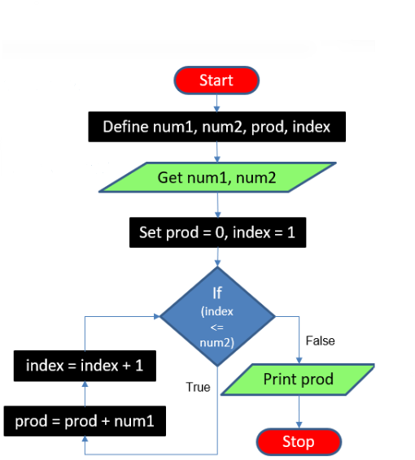
. Mistakes in the Given Flowchart
The given flowchart has the following problems:
- It does not handle negative values correctly.
- It does not check whether either input is zero.
- It always uses num2 as the loop count.
- It does not choose the smaller absolute value as the number of repetitions.
- It does not handle the sign of the final product.
- Therefore, it cannot correctly handle all the required test cases.

CORRECTED FLOWCHART :
START
Read num1, num2

Is num1=0 YES prod = 0
Or num2=0
print prod
NO STOP
Determine sign of result , if exactly one number
Is negative then negative= 1 else negative= 0

a = |num1| ;b = |num2|

is a<b YES interchange a and b
NO
prod = 0 ; index = 1

is index <= b ? YES prod = prod + a
index = index + 1
NO

is negative = 1 ? YES prod = -prod

NO
print prod

STOP

Verification / Test Cases

Test Case | Input 1 | Input 2 | Expected Output | Minimum Additions | Actual Output
1 | 12 | 3 | 36 | 3 | 36
2 | 3 | 12 | 36 | 3 | 36
3 | -6 | 5 | -30 | 5 | -30
4 | 6 | -5 | -30 | 5 | -30
5 | -9 | -4 | 36 | 4 | 36
6 | -4 | -9 | 36 | 4 | 36
7 | 0 | 8 | 0 | 0 | 0
8 | 8 | 0 | 0 | 0 | 0
9 | 0 | -7 | 0 | 0 | 0
10 | -7 | 0 | 0 | 0 | 0
11 | 0 | 0 | 0 | 0 | 0
12 | 1 | -7 | -7 | 1 | -7
13 | -1 | -9 | 9 | 1 | 9

Conclusion
The incorrect algorithm and flowchart were analyzed and corrected.
The corrected solution:
- Performs multiplication using repeated addition.
- Does not use the multiplication operator *.
- Handles positive and negative integers.
- Handles multiplication by zero.
- Uses the minimum possible number of additions by using the smaller absolute value as the repetition count.
- Successfully passes all 13 given test cases
………………………………………………………………………………………….
THANKYOU

NAME – AYUSHI KUMAWAT
SAP ID – 590032252
BATCH – 16 , B.TECH CSE 2026- 2030

